

Development Document

Assessment 2: Utility App
Module Coordinator: Jake Hobbs

Date of submission: 03/02/2022
Number of words: 4,525

The Brief:
My task is to create a Vending Machine program using the C++ programming language. The program should demonstrate your knowledge of programming and make use of the techniques introduced over the course of the module. – GitHub: ArchyCo
https://github.com/CodeLab-I-21-22/utility-app-ArchyCo
Specification

Minimum Features:
The Vending Machine must have the following features as a minimum requirement:
- A menu of drinks and snacks presented via the console. The number and range of items is up to you.
- A set of codes that the user can input to select a particular drink or snack.
- A way of capturing the user’s inputted code.
- A way of managing money. The user should be able to input any amount of money and have the correct change returned.
- A message that tells the user that a particular drink or snack has been dispensed.
- A message that tells the user how much change they have received.
- Comments in the code to explain key operations.

Additional Features:
- A method of categorising items in the vending machine to improve the user experience (e.g., ‘Chocolate’, ‘Drinks’, ‘Crisps’ or ‘Protein Shakes’).
- A way of allowing users to buy additional items.
- The use of functions to improve the structure of your program.
- Music playing in the background of console
- Made console output menu of categories & units in a box of stars
- The use of headers, classes, methods, structures, maps, and macros.

System Flowchart:
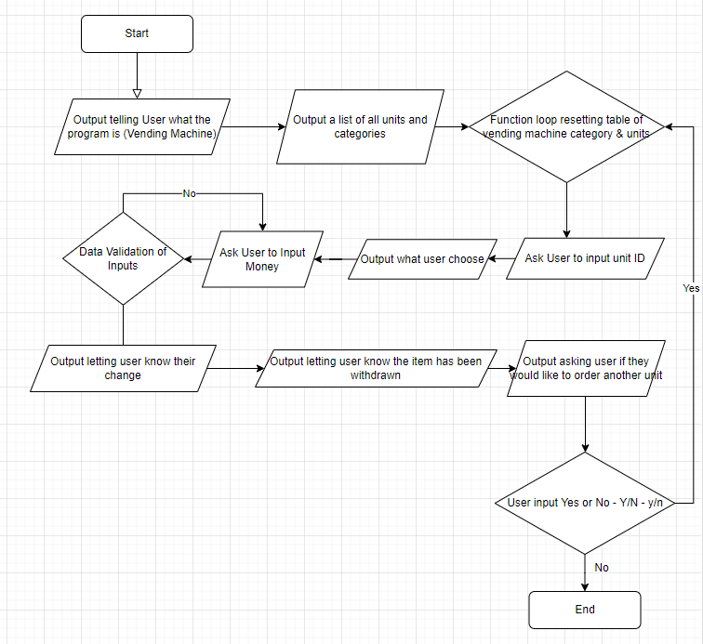

Technical Description:
Key: Header files, Classes, Objects, Functions, Variables, While & For Loops, Used Maps and Structures as container instead of Array, If conditions, Switch/Case statements, Operators, Macros.
My vending machine program uses Classes in the VendingMachine header file - (class VendingMachine) and in Unit header file – (class Unit) which contains private and public attributes, these are in my program’s header files where variables, containers e.g., arrays, lists, map, and functions are declared. There are 16 different functions in VendingMachine.h and 4 functions in unit.h file making for a total of 20 functions in this program.
I used header files for the project to minimize potential for errors and to contain declarations efficiently & neatly.
In this header file I declare private maps and variables and 16 public methods/functions for class VendingMachine
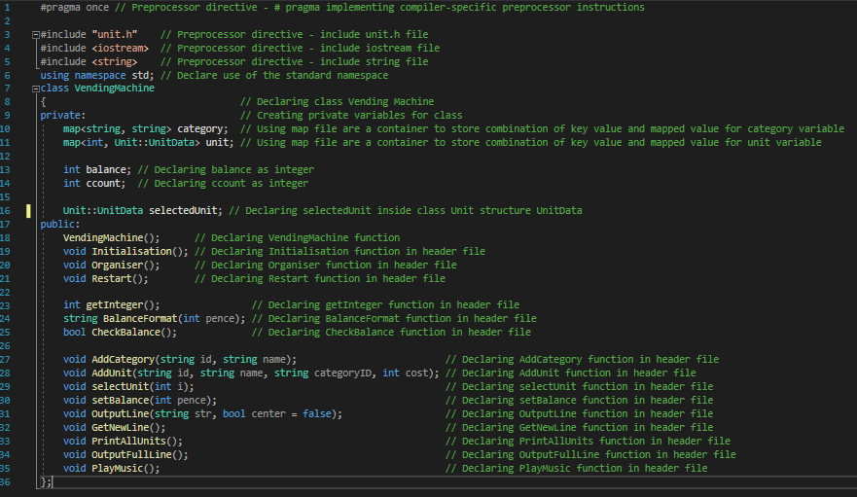
In this header file I declare a private map and declared 3 public functions and a structure UnitData in which the functions contain a variable from the structure.
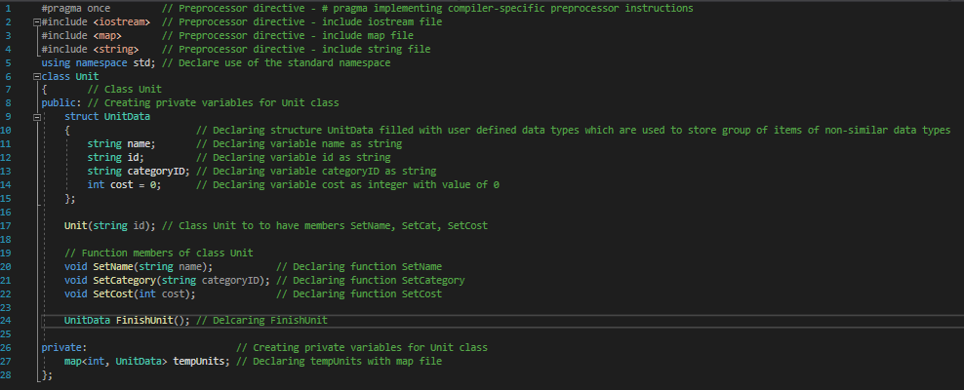

For the last header file configuration.h I used #define to create macros this will allow the constant value that should be declared for the usage, these can’t be changed via code as you would with variables as macros are not variables.
Menu_Header is to output a message
Menu_Width is to define value of 100
CURRENCY is to output £ sign as C++ VS does not like printing £ so tried to force it by using the Unicode Transformation Format (UTF-8) code so it will output the £ sign however this still doesn’t work but $ does.
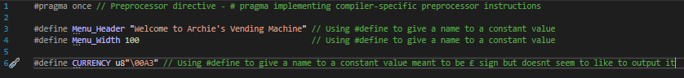
My main.cpp file doesn’t do much other than call VendingMachine class & VendingMachine function.
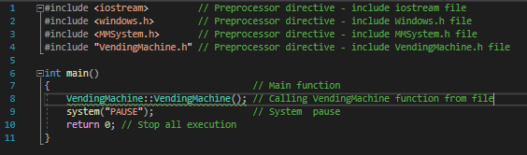
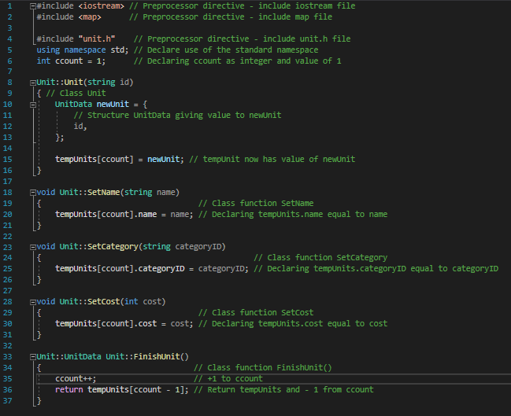
In my unit.cpp file I give class Unit::Unit & methods/functions SetName, SetCategory, SetCost & FinishUnit all values so they can be called and used in VendingMachine.cpp.

The Vending Machine.cpp file is the main file of my program and gives definition to all the methods/functions in VendingMachine.h.
First off I needed to include all the necessary pre-processor directives and header files.
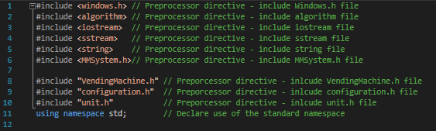
First I use the Class VendingMachine followed the scope resolution :: operator, followed by the VendingMachine function which calls the Initialisation function.
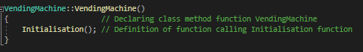
The Initialisation function first initialises ccount variable to have a value of 1 then calls function AddCategory which registers the parameters set inside the function brackets for category’s Crisps, Chocolate, Drinks, and Protein Shakes. Then it calls the function AddUnit also registers the parameters set inside the function brackets but also registers the category and cost of unit. After all the Categories and Units are registered the next function that gets called is OutputFullLine which outputs a full line of stars. Then its PrintAllUnits which prints all the categories and units out. String title calls macro, Menu_Header and outputs it. GetNewLine gets a newline and prints a * and looped spaces. OutputLine function serves as a way of outputting a line or text with certain formatting, so the console output is all in a box of stars. The PlayMusic function plays the music file in the background when program is launched. The Organiser function asks user to enter what unit they want with data validation then calls selectUnit function which passes the data from the Organiser function and uses it for the selectUnit function.
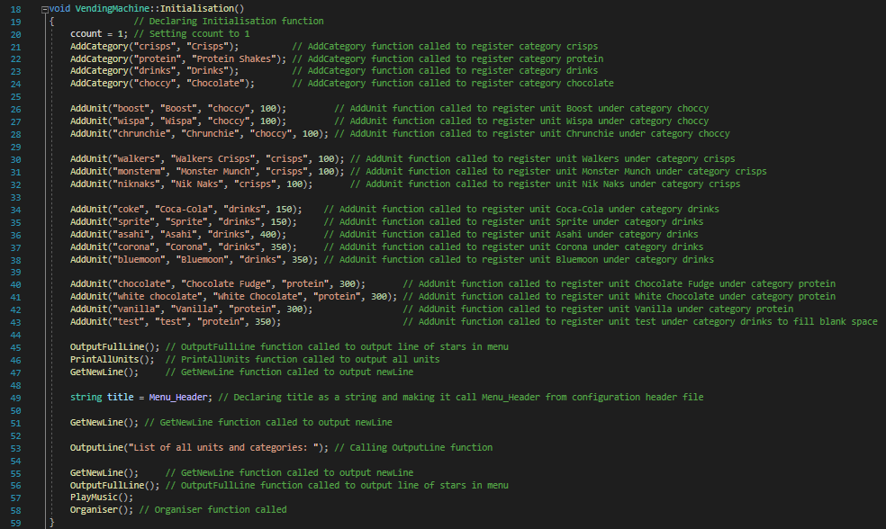

The OutputLine function deals with the formatting of the table by adding a * before and after as well as looped spaces in-between. This function is used to console output text with formatting.
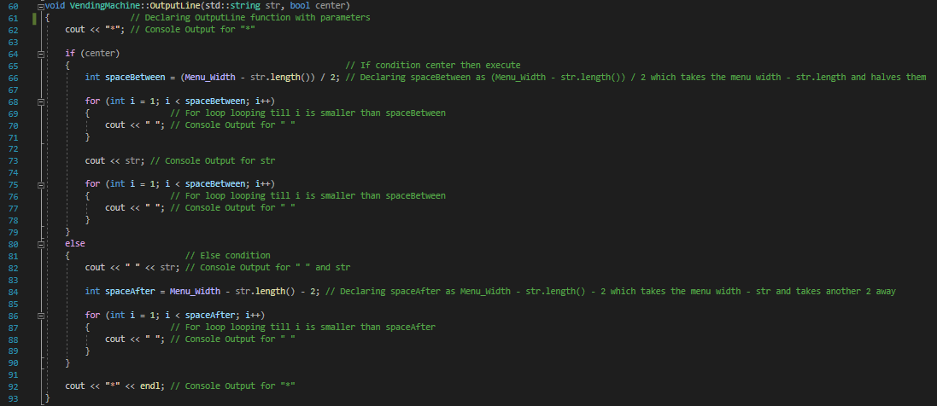
The Restart function clears the console screen by using System to call to OS command line with "cls" command then calls the Initialisation function
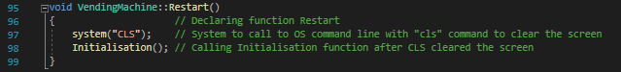
The BalanceFormat function formats the currency and returns the formatted currency as £ however C++ won’t show the £ sign even when put in UTF-8 format just returns blank or a weird symbol which is not the £ sign.
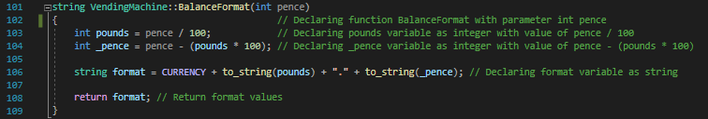
The Organiser function asks the user to input a unit id the variable unitID then gets defined as getInteger function which makes sure its an integer entered and no other data type and serves as a data validating input function, then has a while loop to check if the unit ID entered is on the list of units and while its not ask user to input the correct ID. Then the selectUnit function is called after to select the unit after input, hence organising it all together.
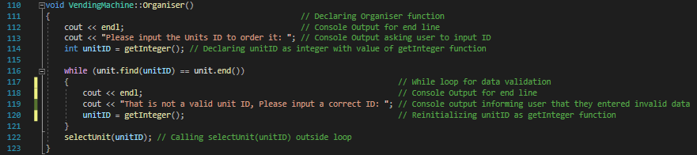

The setBalance function sets the variable balance to pence
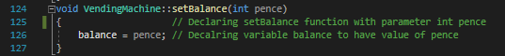
The selectUnit function lets the user know what Unit they selected and how much they need to deposit to purchase the unit the deposit variable also uses the getInteger function for the input to insure the user only inputs integers as it’s a currency. selectUnit also has a while loop in which while deposit variable is less than or equal to 0 please enter more than 0 pence then calls the setBalance function with deposit variable as a parameter to assign balance variable with a value. Then selectUnit uses a if condition with the condition of CheckBalance function. Which then outputs a message letting user know their unit has been withdrawn and their spare change. After that is a case/switch statement which will take the users input of Y/N/y/n for if they want to order another unit.
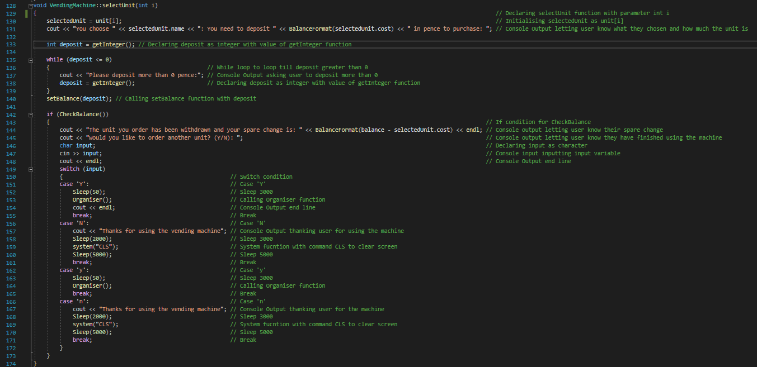
The OutputFullLine function outputs a full line of stars using a for loop
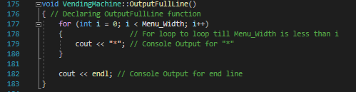
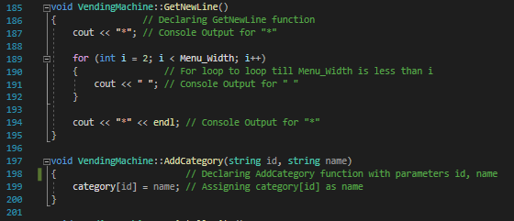
The GetNewLine function outputs a star first then loops “ “ a space till Menu_Width is less than I then output’s another star outside of the loop

The AddCategory function contains parameters id & name which were defined in a structure in the unit header file. AddCategory defines category[id] to equal name.
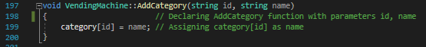
The PrintAllUnits function uses a for loop with auto function which specifies that the type of the variable that is being declared will be automatically deducted from its initializer which then the object it and map function second to give the value for formatting when outputting all units to console.
Then there is another for loop which will loop till unit.size is smaller than I then inside the loop declares unit[i] inside map class Unit::UnitData then an if condition, it->first will give the key element of the pair object pointed to by the iterator and inside the if is OutputLine function called to do some text formatting and output it.
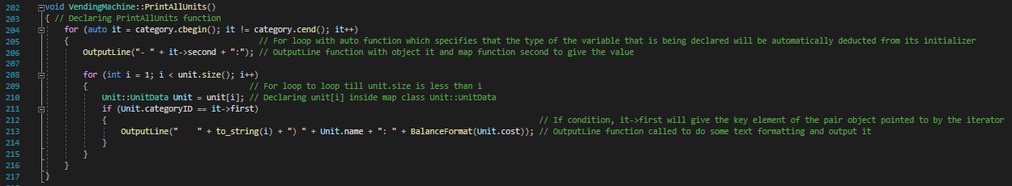
The CheckBalance function is a boolean defined function and uses and if condition to run if selectedUnit.cost is less than balance. Then it outputs a message to the user letting them know they need to deposit more money and how much more they need to deposit then the input is taken using the getInteger function and setBalance is then called after with the parameters balance + deposit. Then if the user fails to enter the correct amount again then output message letting user know they are broke and need to get their money up and restart the whole vending machine program.
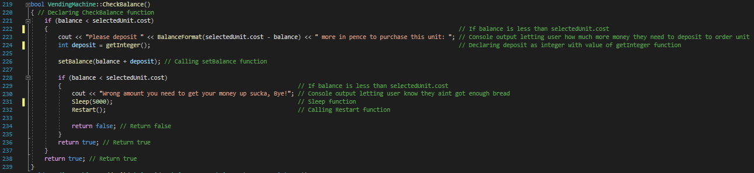

The AddUnit fucntion contains parameters string id, string name, string category id and int cost. Class Unit calling local variable newUnit(id) containing parameter id gets defined to then be used to access methods/functions SetCategory, SetName, SetCost just like you access attributes; by creating an object of the class and using the dot syntax e.g., newUnit.SetCategory(categoryID); with the parameter changing for each similar method to variable name. Then changing unit[ccount] to equal newUnit object calling FinishUnit method, lastly the variable ccount++; means that the variable is incremented by one and the old value is returned.
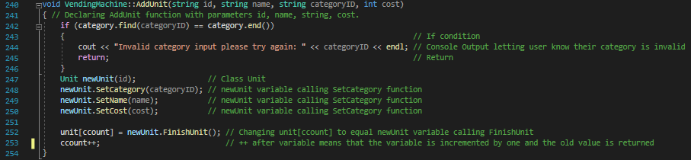
The getInteger function declares two variables one is an integer called i_integer, other is a string called str_number then uses a while true loop to call standard library function getline() with parameters cin, str_number, then stringstream convert(str_number) - associates a string object with a stream allowing you to read from the string as if it were a stream, and convert to convert a word in text form in the string object to a number, and vice-versa. Using and if condition - if (convert >> (The bitwise right-shift operator)i_integer &&(AND) !(NOT)(convert >> ((The bitwise right shift operator))str_number)) to then return i_integer. Next cin.clear is used to clear the error flag on cin (so that future I/O operations will work correctly) and lastly ceer is used to output a message as standard output stream for errors.
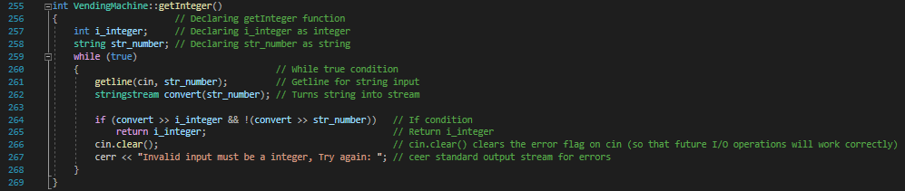
Lastly the PlayMusic function/method has one Boolean variable called play which uses the PlaySound function from windows.h file. This then plays music through the console and SND_ASYNC parameter set so it will play without force stopping everything when called, as that happens when you put SND_SYNC.
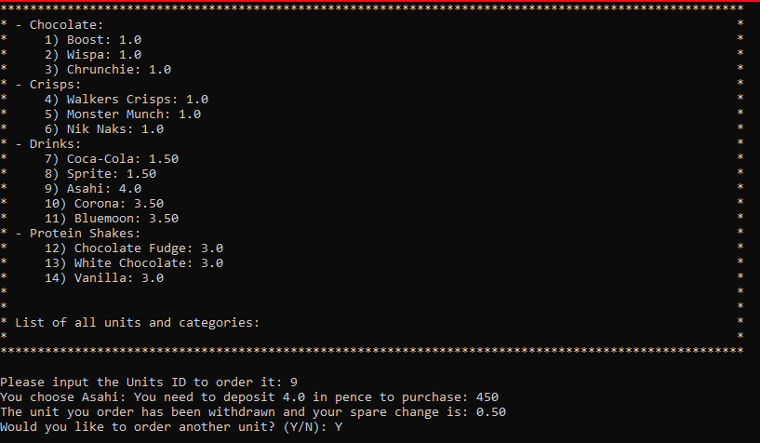

Critical Evaluation:
I know one of the best-looking things in my vending machine is how I displayed the list of categories and units I created a method/function for. This ended up working well with the output looking very organised.
The next good thing about my program is that I created a method/function for the whole vending machine the main Initialiser function just calls all other functions defined after it which makes the program very efficient, less code and more aesthetically pleasing.
I used a lot of different programming techniques into my programming that just haven’t been taught to use through codelab yet though I could have made the program a lot simpler, however that is way less fun.
I know that I could improve this vending machine a lot just by adding a few more features like changing the colour of text, adding a storage/basket system, a way of carrying over inputted money.
Overall, I’m happy with the vending machine was quite fun to be able to do a programming exercise that is a bit more challenging than every other exercise we have done.

Appendix:

Header files:

VendingMachine.h

#pragma once // Preprocessor directive - # pragma implementing compiler-specific preprocessor instructions

#include "unit.h" // Preprocessor directive - include unit.h file
#include <iostream> // Preprocessor directive - include iostream file
#include <string> // Preprocessor directive - include string file
using namespace std; // Declare use of the standard namespace
class VendingMachine
{ // Declaring class Vending Machine
private: // Creating private variables for class
map<string, string> category; // Using map file are a container to store combination of key value and mapped value for category variable
map<int, Unit::UnitData> unit; // Using map file are a container to store combination of key value and mapped value for unit variable

int balance; // Declaring balance as integer
int ccount; // Declaring ccount as integer

Unit::UnitData selectedUnit; // Declaring selectedUnit inside map Unit::UnitData
public:
VendingMachine(); // Declaring VendingMachine function
void Initialisation(); // Declaring Initialisation function in header file
void Organiser(); // Declaring Organiser function in header file
void Restart(); // Declaring Restart function in header file

int getInteger(); // Declaring getInteger function in header file
string BalanceFormat(int pence); // Declaring BalanceFormat function in header file

bool CheckBalance();// Declaring CheckBalance function in header file

void AddCategory(string id, string name); // Declaring AddCategory function in header file
void AddUnit(string id, string name, string categoryID, int cost); // Declaring AddUnit function in header file
void selectUnit(int i); // Declaring selectUnit function in header file
void setBalance(int pence); // Declaring setBalance function in header file
void OutputLine(string str, bool center = false); // Declaring OutputLine function in header file
void GetNewLine(); // Declaring GetNewLine function in header file
void PrintAllUnits(); // Declaring PrintAllUnits function in header file
void OutputFullLine(); // Declaring OutputFullLine function in header file
void PlayMusic(); // Declaring PlayMusic function in header file
};

Unit.h
#pragma once // Preprocessor directive - # pragma implementing compiler-specific preprocessor instructions
#include <iostream> // Preprocessor directive - include iostream file
#include <map> // Preprocessor directive - include map file
#include <string> // Preprocessor directive - include string file
using namespace std; // Declare use of the standard namespace
class Unit
{ // Class Unit
public: // Creating private variables for Unit class
struct UnitData
{ // Declaring structure UnitData filled with user defined data types which are used to store group of items of non-similar data types
string name; // Declaring variable name as string
string id; // Declaring variable id as string
string categoryID; // Declaring variable categoryID as string
int cost = 0; // Declaring variable cost as integer with value of 0
};

Unit(string id); // Class Unit to have members SetName, SetCat, SetCost

// Function members of class Unit
void SetName(string name); // Declaring function SetName
void SetCategory(string categoryID); // Declaring function SetCategory
void SetCost(int cost); // Declaring function SetCost

UnitData FinishUnit(); // Delcaring FinishUnit

private: // Creating private variables for Unit class
map<int, UnitData> tempUnits; // Declaring tempUnits with map file
};

Configuration.h
#pragma once // Preprocessor directive - # pragma implementing compiler-specific preprocessor instructions

#define Menu_Header "Welcome to Archie's Vending Machine" // Using #define to give a name to a constant value
#define Menu_Width 100 // Using #define to give a name to a constant value

#define CURRENCY u8"\00A3" // Using #define to give a name to a constant value

C++ Files:

Main.cpp
#include <iostream> // Preprocessor directive - include iostream file
#include <windows.h> // Preprocessor directive - include Windows.h file
#include <MMSystem.h> // Preprocessor directive - include MMSystem.h file
#include "VendingMachine.h" // Preprocessor directive - include VendingMachine.h file

int main()
{ // Main function
VendingMachine::VendingMachine(); // Calling VendingMachine function from file
system("PAUSE"); // System pause
return 0; // Stop all execution
}

Vending Machine.cpp
#include <windows.h> // Preprocessor directive - include Windows.h file
#include <algorithm> // Preprocessor directive - include algorithm file
#include <iostream> // Preprocessor directive - include iostream file
#include <sstream> // Preprocessor directive - include sstream file
#include <string> // Preprocessor directive - include string file
#include <MMSystem.h>// Preprocessor directive - include MMSystem.h file

#include "VendingMachine.h" // Preporcessor directive - inlcude VendingMachine.h file
#include "configuration.h" // Preporcessor directive - inlcude configuration.h file
#include "unit.h" // Preporcessor directive - inlcude unit.h file
using namespace std; // Declare use of the standard namespace

VendingMachine::VendingMachine()
{ // Declaring Vending Machine function
Initialisation(); // Definition of function calling Initialisation function
}

void VendingMachine::Initialisation()
{ // Declaring Initialisation function
ccount = 1; // Setting ccount to 1
AddCategory("crisps", "Crisps"); // AddCategory function called to register category crisps
AddCategory("protein", "Protein Shakes"); // AddCategory function called to register category protein
AddCategory("drinks", "Drinks"); // AddCategory function called to register category drinks
AddCategory("choccy", "Chocolate"); // AddCategory function called to register category chocolate

AddUnit("boost", "Boost", "choccy", 100); // AddUnit function called to register unit Boost under category choccy
AddUnit("wispa", "Wispa", "choccy", 100); // AddUnit function called to register unit Wispa under category choccy
AddUnit("chrunchie", "Chrunchie", "choccy", 100); // AddUnit function called to register unit Chrunchie under category choccy

AddUnit("walkers", "Walkers Crisps", "crisps", 100); // AddUnit function called to register unit Walkers under category crisps
AddUnit("monsterm", "Monster Munch", "crisps", 100); // AddUnit function called to register unit Monster Munch under category crisps
AddUnit("niknaks", "Nik Naks", "crisps", 100); // AddUnit function called to register unit Nik Naks under category crisps

AddUnit("coke", "Coca-Cola", "drinks", 150); // AddUnit function called to register unit Coca-Cola under category drinks
AddUnit("sprite", "Sprite", "drinks", 150); // AddUnit function called to register unit Sprite under category drinks
AddUnit("asahi", "Asahi", "drinks", 400); // AddUnit function called to register unit Asahi under category drinks
AddUnit("corona", "Corona", "drinks", 350); // AddUnit function called to register unit Corona under category drinks
AddUnit("bluemoon", "Bluemoon", "drinks", 350); // AddUnit function called to register unit Bluemoon under category drinks

AddUnit("chocolate", "Chocolate Fudge", "protein", 300); // AddUnit function called to register unit Chocolate Fudge under category protein
AddUnit("white chocolate", "White Chocolate", "protein", 300); // AddUnit function called to register unit White Chocolate under category protein
AddUnit("vanilla", "Vanilla", "protein", 300); // AddUnit function called to register unit Vanilla under category protein
AddUnit("test", "test", "protein", 350); // AddUnit function called to register unit test under category drinks to fill blank space

OutputFullLine(); // OutputFullLine function called to output line of stars in menu
PrintAllUnits(); // PrintAllUnits function called to output all units
GetNewLine(); // GetNewLine function called to output newLine

string title = Menu_Header; // Declaring title as a string and making it call Menu_Header from configuration header file

GetNewLine(); // GetNewLine function called to output newLine

OutputLine("List of all units and categories: "); // Calling OutputLine function

GetNewLine(); // GetNewLine function called to output newLine
OutputFullLine(); // OutputFullLine function called to output line of stars in menu
PlayMusic();
Organiser(); // Organiser function called
}
void VendingMachine::OutputLine(std::string str, bool center)
{ // Declaring OutputLine function
cout << "*"; // Console Output for "*"

if (center)
{ // If condition center then execute
int spaceBetween = (Menu_Width - str.length()) / 2; // Declaring spaceBetween as (Menu_Width - str.length()) / 2 which takes the menu width - str.length and halves them

for (int i = 1; i < spaceBetween; i++)
{ // For loop looping till i is smaller than spaceBetween
cout << " "; // Console Output for " "
}

cout << str; // Console Output for str

for (int i = 1; i < spaceBetween; i++)
{ // For loop looping till i is smaller than spaceBetween
cout << " "; // Console Output for " "
}
}
else
{ // Else condition
cout << " " << str; // Console Output for " " and str

int spaceAfter = Menu_Width - str.length() - 2; // Declaring spaceAfter as Menu_Width - str.length() - 2 which takes the menu width - str and takes another 2 away

for (int i = 1; i < spaceAfter; i++)
{ // For loop looping till i is smaller than spaceAfter
cout << " "; // Console Output for " "
}
}

cout << "*" << endl; // Console Output for "*"
}

void VendingMachine::Restart()
{ // Declaring function Restart
system("CLS"); // System to call to OS command line with "cls" command to clear the screen
Initialisation(); // Calling Initialisation function after CLS cleared the screen
}

string VendingMachine::BalanceFormat(int pence)
{ // Declaring function BalanceFormat
int pounds = pence / 100; // Declaring pounds variable as integer with value of pence / 100
int _pence = pence - (pounds * 100); // Declaring _pence variable as integer with value of pence - (pounds * 100)

string format = CURRENCY + to_string(pounds) + "." + to_string(_pence); // Declaring format variable as string

return format; // Return format values
}
void VendingMachine::Organiser()
{ // Declaring Organiser function
cout << endl; // Console Output for end line
cout << "Please input the Units ID to order it: "; // Console Output asking user to input ID
int unitID = getInteger(); // Declaring unitID as integer with value of getInteger function

while (unit.find(unitID) == unit.end())
{ // While loop for data validation
cout << endl; // Console Output for end line
cout << "That is not a valid unit ID, Please input a correct ID"; // Console output informing user that they entered invalid data
unitID = getInteger(); // Reinitializing unitID as getInteger function
}
selectUnit(unitID); // Calling selectUnit(unitID) outside loop
}
void VendingMachine::setBalance(int pence)
{ // Declaring setBalance function
balance = pence; // Decalring variable balance to have value of pence
}
void VendingMachine::selectUnit(int i)
{ // Declaring selectUnit function
selectedUnit = unit[i]; // Initialising selectedUnit as unit[i]
cout << "You choose " << selectedUnit.name << ": You need to deposit " << BalanceFormat(selectedUnit.cost) << " in pence to purchase: "; // Console Output letting user know what they chosen and how much the unit is

int deposit = getInteger(); // Declaring deposit as integer with value of getInteger function

while (deposit <= 0)
{ // While loop to loop till deposit greater than 0
cout << "Please deposit more than 0 pence:"; // Console Output asking user to deposit more than 0
deposit = getInteger(); // Declaring deposit as integer with value of getInteger function
}
setBalance(deposit); // Calling setBalance function with deposit

if (CheckBalance())
{ // If condition for CheckBalance
cout << "The unit you order has been withdrawn and your spare change is: " << BalanceFormat(balance - selectedUnit.cost) << endl; // Console output letting user know their spare change
cout << "Would you like to order another unit? (Y/N): "; // Console output letting user know they have finished using the machine
char input; // Declaring input as character
cin >> input; // Console input inputting input variable
cout << endl; // Console Output end line
switch (input)
{ // Switch condition
case 'Y': // Case 'Y'
Sleep(50); // Sleep 3000
Organiser(); // Calling Organiser function
cout << endl; // Console Output end line
break; // Break
case 'N': // Case 'N'
cout << "Thanks for using the vending machine"; // Console Output thanking user for using the machine
Sleep(2000); // Sleep 3000
system("CLS"); // System fucntion with command CLS to clear screen
Sleep(5000); // Sleep 5000
break; // Break
case 'y': // Case 'y'
Sleep(50); // Sleep 3000
Organiser(); // Calling Organiser function
break; // Break
case 'n': // Case 'n'
cout << "Thanks for using the vending machine"; // Console Output thanking user for the machine
Sleep(2000); // Sleep 3000
system("CLS"); // System fucntion with command CLS to clear screen
Sleep(5000); // Sleep 5000
break; // Break
}
}
}
void VendingMachine::OutputFullLine()
{ // Declaring OutputFullLine function
for (int i = 0; i < Menu_Width; i++)
{ // For loop to loop till Menu_Width is less than i
cout << "*"; // Console Output for "*"
}

cout << endl; // Console Output for end line
}

void VendingMachine::GetNewLine()
{ // Declaring GetNewLine function
cout << "*"; // Console Output for "*"

for (int i = 2; i < Menu_Width; i++)
{ // For loop to loop till Menu_Width is less than i
cout << " "; // Console Output for " "
}

cout << "*" << endl; // Console Output for "*"
}

void VendingMachine::AddCategory(string id, string name)
{ // Declaring AddCategory function
category[id] = name; // Assigning category[id] as name
}

void VendingMachine::PrintAllUnits()
{ // Declaring PrintAllUnits function
for (auto it = category.cbegin(); it != category.cend(); it++)
{ // For loop with auto function which specifies that the type of the variable that is being declared will be automatically deducted from its initializer
OutputLine("- " + it->second + ":"); // OutputLine function with object it and map function second to give the value

for (int i = 1; i < unit.size(); i++)
{ // For loop to loop till unit.size is less than i
Unit::UnitData Unit = unit[i]; // Declaring unit[i] inside map class Unit::UnitData
if (Unit.categoryID == it->first)
{ // If condition, it->first will give the key element of the pair object pointed to by the iterator
OutputLine(" " + to_string(i) + ") " + Unit.name + ": " + BalanceFormat(Unit.cost)); // OutputLine function called to do some text formatting and output it
}
}
}
}

bool VendingMachine::CheckBalance()
{ // Declaring CheckBalance function
if (balance < selectedUnit.cost)
{ // If balance is less than selectedUnit.cost
cout << "Please deposit " << BalanceFormat(selectedUnit.cost - balance) << " more in pence to purchase this unit: "; // Console output letting user how much more money they need to deposit to order unit
int deposit = getInteger(); // Declaring deposit as integer with value of getInteger function

setBalance(balance + deposit); // Calling setBalance function

if (balance < selectedUnit.cost)
{ // If balance is less than selectedUnit.cost
cout << "Wrong amount you need to get your money up sucka, Bye!"; // Console output letting user know they aint got enough bread
Sleep(5000); // Sleep function
Restart(); // Calling Restart function

return false; // Return false
}
return true; // Return true
}
return true; // Return true
}
void VendingMachine::AddUnit(string id, string name, string categoryID, int cost)
{ // Declaring AddUnit function
if (category.find(categoryID) == category.end())
{ // If condition
cout << "Invalid category input please try again: " << categoryID << endl; // Console Output letting user know their category is invalid
return; // Return
}
Unit newUnit(id); // Class Unit
newUnit.SetCategory(categoryID); // newUnit variable calling SetCategory function
newUnit.SetName(name); // newUnit variable calling SetCategory function
newUnit.SetCost(cost); // newUnit variable calling SetCategory function

unit[ccount] = newUnit.FinishUnit(); // Changing unit[ccount] to equal newUnit variable calling FinishUnit
ccount++; // +1 to ccount
}
int VendingMachine::getInteger()
{ // Declaring getInteger function
int i_integer; // Declaring i_integer as integer
string str_number; // Declaring str_number as string
while (true)
{ // While true condition
getline(cin, str_number); // Getline for string input
stringstream convert(str_number); // Turns string into stream

if (convert >> i_integer && !(convert >> str_number)) // If condition
return i_integer; // Return i_integer
cin.clear(); // cin.clear() clears the error flag on cin (so that future I/O operations will work correctly)
cerr << "Invalid input must be a integer, Try again: "; // ceer standard output stream for errors
}
}
void VendingMachine::PlayMusic() { // Declaring PlayMusic function
bool play = PlaySound(TEXT("Music.wav"), NULL, SND_ASYNC); // Declaring play as boolean with function PlaySound to play sound
}

Unit.cpp
#include <iostream> // Preprocessor directive - include iostream file
#include <map> // Preprocessor directive - include map file

#include "unit.h" // Preprocessor directive - include unit.h file
using namespace std; // Declare use of the standard namespace
int ccount = 1; // Declaring ccount as integer and value of 1

Unit::Unit(string id)
{ // Class Unit
UnitData newUnit = {
// Structure UnitData giving value to newUnit
id,
};

tempUnits[ccount] = newUnit; // tempUnit now has value of newUnit
}

void Unit::SetName(string name)
{ // Class function SetName
tempUnits[ccount].name = name; // Declaring tempUnits.name equal to name
}

void Unit::SetCategory(string categoryID)
{ // Class function SetCategory
tempUnits[ccount].categoryID = categoryID; // Declaring tempUnits.categoryID equal to categoryID
}

void Unit::SetCost(int cost)
{ // Class function SetCost
tempUnits[ccount].cost = cost; // Declaring tempUnits.cost equal to cost
}

Unit::UnitData Unit::FinishUnit()
{ // Class function FinishUnit()
ccount++; // +1 to ccount
return tempUnits[ccount - 1]; // Return tempUnits and - 1 from ccount
}

